
Social Media Marketing
Getting Started
Training Workbook

Social Media Marketing
Issue 1.0
©Shaklee Corporation.
Every effort has been made to ensure that the information contained in this document is true and correct at the time of going to press. However, the systems, processes, specifications and content in general described in this document are subject to continuous development and Shaklee Corporation is entitled to change them at any time and to expand on them.
All names and other data used in examples are fictitious.
Any websites or companies referenced in this document are for reference only and should not be considered an endorsement.
Table of Contents
Purpose of the Workbook….…………………………………………………..............................................2
Course Objectives 2
What is Social Media Marketing 3
How can social media marketing help me build my business? 8
Social Media Etiquette 11
Using Facebook Effectively 12
Using Twitter Effectively 14
Make a Plan 15
Homework 20

Purpose of the Workbook
The purpose of this workbook is to introduce some basic methods of social media marketing, as well as provide instructions on how to get started using social media to market your business. For further information about Social Media Marketing, email itrack@shaklee.com.
Course Objectives
By the end of this course, you will:
- Become familiar with the basic tenets of Social Media Marketing and how to market using these techniques.
- Create your online profile.
- Set up a plan to begin marketing your product and opportunity
- Create a plan to measure your success
- Receive information about online and webinar training.

What is Social Media Marketing?
Social media marketing is a way to reach people who are part of your target audience by becoming an active participant in relevant communities and conversations.

What is social media? Social media is described as any form of online publication or presence that allows users to engage in conversation with each other. In other words, the content created is freely shared by all to encourage interaction between the viewers.
What are social media sites? Social Media websites are sites that anyone can join to share their content, ideas, and thoughts in one place. Social media sites are like going to a dance – lots of people there – many you don’t know personally – and they’re all excited and talking about being at the dance. Just by being “at the dance”, you can join in on conversations and it’s considered acceptable.
There are many more social media websites out there than you will ever need. The most popular, Facebook.com, Twitter.com, Stumbleupon.com, myspace.com, are easy to use and very active; however, they may not be the right sites for your message and may not connect you to your target audience.
Some sites focus on specific types of information. The members of the site contribute to the community with articles, comments and interaction with other commuity members. Join sites that will allow you to actively participate and contribute to a community with the same or similar interests that you have. Creating a ‘buzz’ on these sites will result in increased interest in you and what you offer.
Two-thirds of the world’s population are using social media sites. They read and interact with people from all over the world, sharing content, thoughts and increasingly services and products. People join sites and are introduced to an entirely new audience daily.
You can become someone that influences a sphere of complete strangers by joining these sites and actively participating. The people you interact with will, once they begin to trust you, refer you to others – both on and off line.
Buzz – anything that creates excitement or stimulates conversation about a topic.
Notes:

With so many sites to choose from, how do you know which sites to join? First, you need to understand what these sites do, then find the best fit for you. You’ll have to do a bit of research. Finding the sites where it’s appropriate to share your content is almost as important as the content you’re sharing.

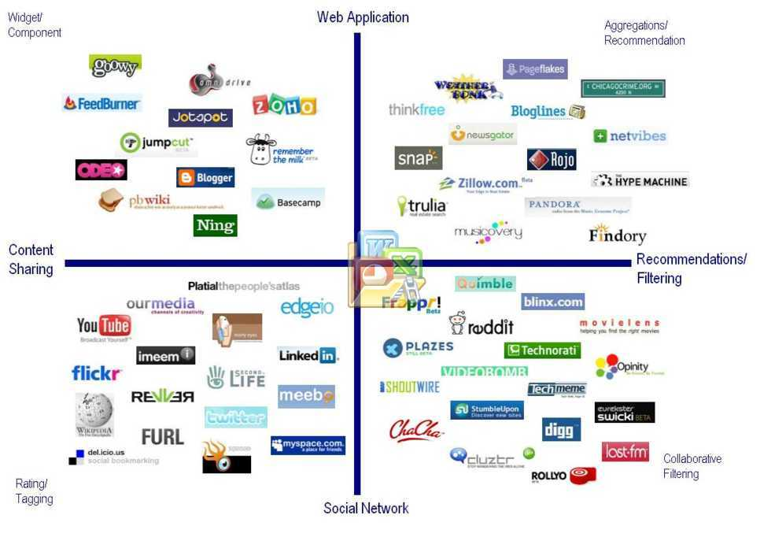

In the diagram above, there are four general types of social media sites: Web Application Sites, Recommendation or Filtering Sites, Social Networks and Content Sharing Sites. By understanding what these sites do, you will find your place in the social media landscape.
Next, we’ll define the types of social media sites.
Notes:

Web Application Sites: Sites that share, make recommendations and review web applications. Some sites provide services – both paid and free - while others are for users to make their internet experience more personal.
For example, pageflakes.com allows users to create a personal homepage on the web that carries their favorite web content (news, weather, sports, entertainment, etc). It can be accessed from anywhere an internet connection is available. Users can collaborate on their page with friends or publish to everyone on the net.

Notes:

Recommendation/Filtering Sites: Created by users to share everything from websites to individual articles, from music websites to technology, from music to clothing stores and cake mixes. The sites themselves identify the topics and industries discussed on each site. Filtering sites will “filter” the information out on the web to find only the topics that the site is interested in discussing.
For example, Digg.com and Reddit.com are social sites – aggregators that allow the community of users to share links to content from the web and discuss that content with others. Users can also upvote or downvote shared content.
Aggregator – tool that collects content from the web and stores it in a single location for easy viewing.
Upvote – on specific sites, an upvote is “like” or approval of the content. Many sites compare upvotes to downvotes to decide what content to display on the home page.
Downvote – on specific sites a downvote is “dislike” or disapproval of the content.

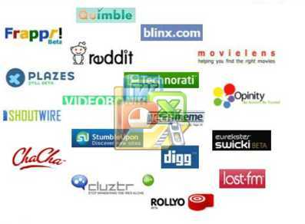
Notes:

Social Networks: Sites people join – some with a specific topic or area of interest – to interact with others on a social basis. Think of this like a cocktail party everyone in the world is invited to attend – you’ll meet people you do know and their friends and people you DON’T know and their friends! Some people are sharing specific content like videos, while others are taking part in a virtual life experience. The common thread here is interacting with others.
For example, youtube.com is a video sharing platform that allows users to upload videos and comment on them, share them with others and share other users’ videos. Youtube users build a community of channel subscribers platforms that allows users to create their own web content.
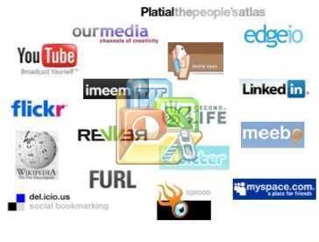
Notes:

Content Sharing: User generated content on any subject deemed of value by the users. Many sites are content-specific while others allow any kind of content. These sites can be anything from blogs to how-to instructions for any number of topics.
For example, Ning.com is a platform that allows users to create their own social network.


Notes:

What sites should I join?

Join sites where you feel that you will be able to know the audience and think about what you can contribute to the community. You will need to spend time fostering relationships with the members of the sites. Build trust. The more supporters you have, the more likely they will recommend your site to others.
One way of building trust is to rate products and content submitted to the site. Writing a concise, well-thought out review or submitting a comment is a great way to get noticed more on line.
Rating allows the users of a site to increase or decrease the visibility of content by “liking” or “disliking”. Users who regularly write reviews and rate products and content have a greater weight applied to their ratings than those who do not. This also makes the rater more visible on line.
Be a content creator – using ratings, comments, uploading videos and images.

Notes:

How can social media help me build my business?

The more people you are connected to, the faster word spreads about you and what you have to offer.
Social media provides excellent opportunities to identify target audiences where you can provide valuable information they need. Social media and direct sales go hand in hand because you can:
- Connect with new people by meeting them at their point of need
- Re-engage with previous customers and provide better and more consistent follow up
- Gain referrals from people who appreciate your information
- Present your opportunity to the people who are looking for one
- Learn what makes your prospects tick so that you can authentically connect with them
- Team support – save time, combine efforts and become more efficient in your communications techniques
Social media cannot replace your core business activities, which are to sell, meet and recruit. If you neglect your money-making activity in favor of social media, you will fail.
Social media merely enhances your ability to conduct your core business activity by targeting your efforts and helping you to work more efficiently while meeting people you wouldn’t normally have the opportunity to meet.
It’s important to join the right communities and then to interconnect your profiles on different social media sites. Make sure that if you belong to Facebook and Digg, you can be found by users of both sites. Get your warm market to share your profile with their warm market, too. What are friends for?

Notes:

How can I use social media effectively?

Social media does not mean free advertising. Instead, it’s a way to meet people and begin networking with them. You offer tips and advice. You’re building a relationship so that they can come to know, like and trust you. You can connect groups of people from different communities to each other, thus increasing your sphere of influence!
When people have a problem, they don’t google YOUR NAME, they google their problem! For instance, “how do I get rid of corns” is what they’ll search for. The more focused your content, the easier it is for people to find you and want to connect with or follow you. They will not respond positively to a sale page – meaning “I got stuff, come buy it!”. Instead, offer your advice and allow the audience to see that you are a person who offers valueable information.
You need to be visible on the sites that you join. Submit content, vote on other content, make comments, be seen! You’re developing your brand – you – and the more visible you are, the more opportunities to interact with others you will have. You need to regularly post on the sites, whether it’s an article or comments on others’ articles.
This is not an opportunity to sell or hype your product or opportunity. This is simply sharing your knowledge and experience. People who want to know more will ask or follow you to your site(s) and subscribe to your information. You will provide a means for them to follow you on Facebook, Twitter, etc, but you will not be making overt offers. Even if someone asks for information or you see an opportunity arise, you conduct that business privately – either through an email or private message through the site.

Notes:

The Personal versus the Professional You
It’s important to decide your primary focus in using social media. People who use social media for personal use do so primarily to keep up with people they already know. Their profile has private information that should not be shared. They know you and they like you.

When using social media for business, your focus is on finding new people while continuing relationships with your friends. Your profile is public and should only contain information that will help the audience get to know you, like you and trust you:
- Interests, Hobbies, Activities
- Education background, Community involvement
- Music and literary favorites
Remember, too, that not everything about you should be shared. Before sharing, you need to decide if any of your potential audience would be offended by that…you could lose an opportunity just because someone doesn’t like someone you do like. Avoid sharing hot topics like religious beliefs, political beliefs, etc. Even something you perceive as a joke could be perceived as offensive by your prospects.

Your Profile

Who are you? What do you do? When people search for you on line, what do they find? What characteristics of your personality should you display that will attract attention in the social media arena? Sell your skills, abilities and personality.
This is not where you give a testimonial. This is a very brief article about who you are, what you can do for others, why people should want to partner with you. Brag about accomplishments that are universal – a prospect won’t understand “Executive Coordinator in 6 months”, but they will understand “rapid growth to a mid-5 figure income”.
The three most important things that must be a part of every profile you create are:
- Your Name
- An easy-to-type valid email address
- Your web address
People need to be able to find you and contact you!

Social Media Etiquette

I always recommend that you “watch” a site before you join. See if you can find their “rules of engagement”…because failure to comply with a site’s etiquette can have much farther reaching effect on your online persona that you can imagine. Here are some basics:
1. It’s SOCIAL media – Invest the time to build relationships first. People don’t appreciate you trying to “sell” them online when you first meet them. For example, introduce yourself to the community or group. Let them know why you’re joining them.
2. Only share business messages with those who have opted in – “Join my team” and “Buy my stuff” posts are not appropriate status updates to blast to all your friends. Save those for your Group, Page, Newsletter, or other opt-in community members.
3. Specific business offers should be made privately – If you see an opening from a specific person, and have a relationship with them, follow up with a phone call or private message.
4. Post appropriately – Everything you post should be appropriate for your company, customers, kids and mother to see.
5. Be nice – Nothing is gained by arguing or complaining on social networks. If there’s an issue, address it privately, not in public for all to see. Remember, too, that these online arguments will remain public long after the issue has been resolved.
6. Avoid sensitive issues – Remember that your online friends may be offended by strong opinions or topics, and what you post may reflect on every salesperson in your company.
Your business isn’t social media; rather, it is to use social media to build your business.

Notes:

Using Facebook Effectively
It all starts with your profile. These are important guidelines to follow:

- Photo – a good, close headshot of you so that people can see who you are. See your expression. This is not an appropriate place to show your dog, your child or a poster from your favorite movie.
- Use your full real name. You are building a brand – you – and your company is not your brand. You must be authentic on line and your name is you.
- Be specific about your business: “I’m a stay-at-home mom who owns her own wellness company”. Not “I can show you how to make millions and be the healthiest person ever!”.
- Provide links to your sites that are public. You always want people to find your sites.
- Make friends in your target market – use the Friend Suggestions from Facebook to review others’ profiles to see if they are a possible prospect.
- Invite people you meet in real life to ‘friend’ you (friend them first in case they don’t remember!) and use Facebook to get them to know, like and trust you.
- Use community pages for prospecting and follow up. Community pages are niche markets!
- Pages – leave it to the parent company to create a business page. You use your personal profile to build relationships.
- Groups – subdivide your contacts into groups dedicated to specific topics. Join other groups that engage in the activity related to your target market and become someone they know, like and trust. Prospect HERE, not on your wall.
- Make yourself easy to find. Most people don’t reorder because they can’t remember how or where to go.

Good updates versus bad updates

The number 1 rule of social media – DON’T SPAM. Examples of spam:
- I’ve started a new business. Come see!
- I’ve got three spaces left at my business party – grab it before it’s too late!
- My product cures cancer and relieves back pain! Buy some!
- I can show you how to earn $100,000 this year!
- I’m having a SALE! Buy my products right now and you’ll save 50%. Shop now! Here’s my link…

- The study evaluated multivitamin use and heart attack risk in 31,671 women with no history of cardiovascular disease (CVD) and 2262 women with a history of CVD aged 49–83 in Sweden. During 10 years of follow-up, in the CVD-free group, use of multivitamins only was associated with a 27% lower risk for heart attack compared with non-us...ers of supplements. Users of multivitamins together with other supplements had a 30% lower risk for heart attack than non-users. Use of multivitamins for 5 years or more was associated with 41% lower risk for heart attack. The authors conclude that use of multivitamins is associated with a lower risk of heart attack, especially long-term use among women with no history of CVD, and that further research is needed to confirm or refute these findings
- Did you know that most makeup is full of harmful chemicals? Try this natural makeup instead!
Appropriate types of messaging:
- Here’s an article that with helpful tips on natural skin care!
- Heading to Bora Bora for Free – Thanks, Shaklee!
- *sigh* So proud of my team – they earned a free trip to San Francisco and Napa Valley – I love my job!
- My age spots have faded – I am so excited! No more granny hands!
- Just finished a great workout – ½ hr longer than usual and still amped! My protien shake is totally energizing me!

Notes:

Pre-sell Messaging
One of the places people most often fail in social media is appropriate messaging. If you want to introduce a product to your niche market, how do you do it? The manufacturer will have all the features and specifications of the product and many times distributors are tempted to regurgitate that information. Resist the impulse to build a fancy splash page touting the benefits of the product – leave that to the manufacturer. Instead, you should offer complementary or first-hand testimonials on the product. How? Reviews and product comparisons. You can place these on a blog, tweet them, update your wall and other share sites.
Get examples from Kathleen

Likeable Content
It’s very important that your content does not “sell” but rather “offers” value. Here are some examples of how you can create likeable content for Facebook and Twitter:
Post photos – instead of using words, use images. Example: Do you have age spots? Did you notice them fade after taking Vivix? You could post before and after photos with a simple comment – look how great my hands look now! Or – before Vivix – and 30 days after vivix!
Post videos – create videos from 30 seconds to 2 minutes and share them. What is the video about? Anything from a testimonial to a how-to for Get Clean to just something funny. Remember, the goal is to engage – not sell.
Share links to other articles that you find interesting. Not all have to be about health or wellness. What else are you interested in? Give your viewers a more well-rounded glimpse of yourself.
Questions – ask questions! Many times people are not responding because you didn’t ask them to. Get a conversation started about anything – especially something where you can speak with authority.
“You” focused messaging – Structure your message focusing on the reader – not you, your product or opportunity. Speak to your audience’s problems first.
Content isn’t about selling…it’s about answering questions people may not have asked yet. It’s about setting yourself up as a resource for answers. You have to think of ways to lead the conversation to what it is you want them see.

Using Twitter Effectively
Twitter can be used to broadcast links, specials and more. Try these tricks of the trade!
- search.twitter.com and join conversations

- Ask questions, agree with them, challenge them
- Ask people to review your site/content via tweets
- Ask your friends to tweet your url - direct traffic to your article (blog)
- Read the news and tweet comments
- Befriend people/track their messages – it’s a way to increase your circle
- Have your followers re-tweet your links
- Tweet a link to your online content and ask them to vote for you (digg)
- Create a Bio that tells people who you are and what you do
- Tweet about your passions and then hash-tag them. Quality content with an easy way to find it never fails!
- Talk about your Twitter account when you speak in public, present slides or hand out business cards.
- Tweet pictures of interest to the general public! As word of your image spreads, you’ll be introduced to an entirely new network of people.
- Copy successful tweeters’ style. Figure out what your style is from there!
- Track your results at twittercounter.com or Qwitter.com

Notes:

What are hashtags?
Hashtabs or # is a way of grouping your tweets on Twitter. Using keywords in your tweets, simply add the # before the keyword in your tweet. In other words, you want to find out the keywords that are trending and then group your tweet in with that to increase your tweet’s visibility.
For example:
"I can't believe anyone would design software like this! #microsoftoffice"
microsoftoffice is a keyword. You can find out about trending hashtags at hashtags.org
Don’t use trending hashtags in messages that have nothing to do with the topic just to reach new people. This is considered spam. Instead, create new hashtags to start new conversations. Be sure to conduct a search to see if your intended hashtag is already in use. If so, just join that conversation.

Notes:

Make a plan!
If you’re going to be successful in using social media to build your business, you need a plan. Here are some questions you should ask yourself:
- What is your goal?
- Who is your target audience?
- When do you have time?
- Where does your target market congregate on line?
- How will you measure your success?


Notes:

Goals

What do you want to accomplish? Limit yourself to 1 or 2 goals when you’re getting started.
What are goals? Goals can be finding new customers, getting orders from people who haven’t ordered in a while, recruiting new prospects or even more specific – sponsoring a world class runner.
Make sure you keep the goal simple and realistic. You are just getting started and small successes will pave the way to larger ones.

Who are you going to target?

Focus your efforts on a specific target or niche market to maximize your efforts. In other words, instead of weeding through the entire population of a state for a prospect, narrow it down and start with a neighborhood in a city! By focusing on a specific target, you can customize your goals to work with your target audience. Be specific! Are they married? Only female? Own pets? What is your buyer’s persona?
Examples of target audience:
- Seniors with who use the wrong make-up
- Swimmers who have joint damage
- Gen Y-ers looking for an income opportunity
- Current customers to place re-orders
- Prevention of late-onset Alzheimer’s
Whatever your target, make sure that you have expertise and can offer free advice and tips to them to encourage them to get to know you, like you and trust you.

Notes:

Setting aside time

It’s very important to decide how much time you will spend on this activity. It requires daily contact, but cannot replace your core income producing activity. You need a minimum of 20 minutes per day to be effective. Put the time into your calendar and schedule it every day.
Make a list of the tasks you feel will help you reach your goals. Stick to the list. Do not let distractions keep you from completing your tasks. That means no Farmville, Mafia Wars or other games found on line!

Finding where your target audience is on line

There are many ways to find your target audience. Let’s start with some basics:
Facebook – Family and Friends, Extended Warm Market. There are tremendous opportunities for relationship building, follow-up, and reorders. You must have only 1 profile! Do not have a personal account and a business account – it is against the rules and you will be removed from Facebook. Use your profile to share personal info that will help you build relationships, but do not share private information. Have your customers post positive reviews of products and service
LinkedIn – Business Profile for Recruiting. Show ALL your business experience and gather recommendations from colleagues. Answer questions and demonstrate expertise in your field. Make sure the opportunity page of your PWS is the URL in your link – you never know when someone is going to get tired of Corporate American and want to try something new. This is a place where you allow prospects to come to you – do not sell here!
Blog (Blogger.com, etc.) A blog is your home base on the web. Demonstrate expertise and meet people at their point of need. These types of sites can generate leads because of referrals by readers. NOTE: Wordpress.com does not allow MLM blogs
Twitter – Share resources and learn from others. Use keywords to identify prospects. Share resources and engage in conversations on topics related to your target audience. Follow people you can learn from – use hash tags and retweets, get your friends to tweet positive reviews of products and services

Measure your results

Whatever your goals are, they must be measureable. For instance, if your goal was to increase sponsoring, you have to be able to count which of the new recruits came from your social media efforts. Volume increase? How many orders were because of social media activities?
Knowing what activites result in successes will also help you refine what does and does not work for you.

Other helpful hints to get involved

In order to broaden your sphere of influence, you must be heard. How do you know where to go, what conversations to join or even how to join them? Here are some helpful hints:

- Google Alerts – create alerts and have conversations about specific subjects emailed to you so that you can respond to them in real time or during your prescribed “social media time”.
- Alltop.com: This website aggregates the top posts from the top blogs around the world and sorts those posts into topics. You can find new blogs to read and interact on based on topics you choose.
- RSS Feeds: Use RSS feeds to follow conversations on other sites so that you can respond in real time and save time looking up your conversations.
- Find the top videos being watched on youtube and comment or respond to comments on that site
- Friendfeed.com is a great way to find hot topics of the day to make sure that you’re keeping up with trends, tools or techniques and more. Become a “newsmaker”!
- Google your interests and see what is out there…join and engage!
- Socialmention.com is a site you can search for phrases for people seeking opportunities or products and engage with them in a conversation.

Homework
Identifying your brand
It is important that you are able to speak with authority and ease about your topic. Write down 3 subjects or topics that you feel you are knowledgeable about.

1.

2.

3.

Identifying niche markets online
It is important that you find the right communities to join. Write down 3 types of audiences who would appreciate content about your brand.

1.

2.

3.

Identifying your buyers’ personas
What about your buyers can you target to trigger action by them? This is any information that is of value to your potential buyer.

Niche Market 1:
1.

2.

3.

Niche Market 2:
1.

2.

3.

Niche Market 3:
1.

2.

3.

Task list
What tasks can you do using social media that will help you reach your goals? Write down the task and how much time per week you think it will take you to accomplish each.

1.

2.

3.

4.

5.

6.

Content Excercise
Using the source content provided, create content for use with 3 different types of social communitites. Note: the hyperlink is fake. You can use it in your content, but it will not navigate to an active page.

Source Content – CNN.com:
Authors of a new study published in the Journal of the American Medical Assoc.(http://www.ama.com/breastcancersoy) concludes that "among women with breast cancer, soy food consumption was significantly associated with decreased death and recurrence." This research conclusion is an extremely important message regarding the positive research in support of soy food intake in women with existing breast cancer. In the past, physicians have often warned breast cancer patients not to eat soy. The new research represents "a complete turnaround" from the previous understanding about the link between soy consumption and breast cancer, says Sally Scroggs, a registered dietician and senior health education specialist at M.D. Anderson's Cancer Prevention Center in Houston, Texas. We have gone from saying, 'No soy for breast cancer survivors' to, 'It's not going to hurt,'" Scroggs says. "Now it looks like we can say, 'It may help.'"
Women who ate between 9.5 and 15 grams of soy protein saw nearly the same decrease in risk as the women who ate more than 15 grams. In fact, the researchers found no additional benefits to eating more than 11 grams of soy protein a day. (An 8-ounce glass of soy milk and a cup of shelled edamame contain about 7 and 14 grams of soy protein, respectively.) In all, 534 women had a breast cancer recurrence or died from breast cancer during the study period.
Soy foods--such as milk, tofu, and edamame--are rich in naturally occurring estrogens (especially isoflavones) that can mimic the effects of estrogen in the female body. Because the most common types of breast cancer depend on estrogen to grow, experts once feared that soy isoflavones could stimulate the estrogen receptors in breast-cancer cells, even though the estrogens in soy are much weaker than those produced by the body. The current study suggests the exact opposite: Soy may actually reduce the amount of estrogen that's available to the body.

- Create a Facebook wall update
- Create a Twitter update using the hashtag #powerofsoy
- Create an appropriate public comment to append to the CNN.com news article.

